Varidhi - Intelligent Vertical Farming System
AI-Optimized Vertical Farming System for Real-Time Crop Management and Increased Yields.

INTERNAL INVENTOR(S)/STUDENT(S):
Full name | Vaibhav Pratap Deo, Varnika Rathi, Monalisa
Mobile Number | 6204999073, 7060073865, 9470802090
Email (personal) | vaibhavpdeo0028@gmail.com  varnikarathi24@gmail.com  monalisabxr@gmail.com
UID/Registration number | 12305836, 12318240, 12301005
Address of Internal Inventors | Lovely Professional University, Punjab-144411, India
Signature (Mandatory) |   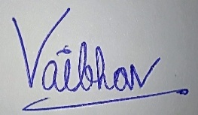  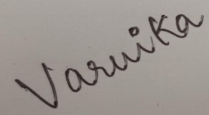

Abstract:
Imagine farms that grow more food with less water and land, right in the heart of our communities. This invention brings that vision to life. We've developed a smart vertical farming system that uses artificial intelligence to perfectly tailor growing conditions for each plant. Think of it as a personal trainer for your vegetables! By precisely controlling light, water, nutrients, and even air quality, our system dramatically boosts yields compared to traditional farming, especially in India's diverse and often challenging climate. This technology aims to make fresh, healthy food more accessible and sustainable, helping farmers thrive and feeding our growing nation more efficiently.

A. DESCRIPTION OF THE INVENTION:
A.1 FIELD OF THE INVENTION:
This invention relates to the field of agriculture, specifically to controlled environment agriculture and vertical farming systems. More particularly, it pertains to an AI-optimized vertical farming system designed to enhance agricultural productivity and resource efficiency, with a focus on addressing the unique challenges and opportunities within the Indian agricultural landscape.
A.2 BACKGROUND OF THE INVENTION:
Traditional agricultural practices in India face significant challenges, including:
- Limited Land Availability: A growing population and urbanization are putting pressure on arable land.
- Water Scarcity: Many regions experience water shortages, impacting crop yields.
- Climate Change: Erratic weather patterns, including droughts and floods, disrupt traditional farming practices.
- Post-Harvest Losses: Inefficient storage and transportation contribute to significant food waste.
- Need for Increased Food Production: To meet the demands of a growing population, there is a critical need to increase agricultural output.
- Pesticide Usage: High pesticide usage causes harm to the environment and the health of the consumers.
Vertical farming offers a potential solution by enabling year-round crop production in controlled environments, maximizing space utilization, and reducing water consumption. However, existing vertical farming systems often lack the intelligence and adaptability needed to optimize growing conditions for diverse crops and specific regional climates. There is a need for a system that can address the specific challenges of Indian agriculture, including climate variability, resource constraints, and the need for affordable and accessible technology for farmers.
A.3 SUMMARY OF THE INVENTION:
This invention provides an AI-optimized vertical farming system that addresses the limitations of traditional agriculture and existing vertical farming methods. The system integrates a multi-layered growing structure with an environmental control system, a hydroponic/aeroponic/aquaponic system, and an AI-powered monitoring and control system. Machine learning algorithms analyze sensor data to optimize growing conditions in real-time, while image analysis and plant health monitoring detect diseases and nutrient deficiencies.
Key aspects of the invention include:
- Real-time optimization of environmental parameters (temperature, humidity, light, nutrients) using AI.
- Automated monitoring and control of plant health through image analysis.
- Efficient water and nutrient delivery through a soilless cultivation system.
- Adaptation to the specific climate and crop requirements of India.
- A user interface that is easy to understand, and use, by the average indian farmer.
- A system that can adapt to the fluctuating power avalability of rural India.
- Energy efficiency through the use of LED lighting and other power saving methods.
- The ability to greatly reduce or eliminate the need for pesticides.
- This system aims to enhance agricultural productivity, reduce resource consumption, and provide a sustainable solution for food production in India.

B. OBJECTIVE OF THE INVENTION:
The primary objective of this invention is to address the challenges of traditional agriculture in India, including:
- Limited land availability.
- Water scarcity.
- Climate change impacts.
- Post-harvest losses.
- Need for increased food production.
This invention seeks to provide a sustainable and efficient alternative that:
- Increases crop yields.
- Reduces water consumption.
- Minimizes land usage.
- Enhances food quality and nutritional value.
- Creates new economic opportunities for farmers.
- Reduces pesticide usage.

C. STATE OF THE ART/ RESEARCH GAP/NOVELTY:

Sr. No. | Patent ID | Abstract | Research Gap | Novelty
1 | US10803312B2 | Ai-powered autonomous plant-growth optimization system that automatically adjusts input variables to yield desired harvest traits | Difficulty in determining the optimal timing and application of spectral output and intensity variations for plants. | Use of AI and IoT to automate plant growth optimization in indoor farms
2 | US8533993B2 | A continuous-loop conveyor, towering upon vertical framework, which allows potted perennial plants and other plants to be transported throughout all stages of maturity. | Highlights the difficulty in determining optimal conditions for plant growth due to the subjective, inefficient, and labor-intensive nature of manual measurements. | Using of AI and IoT for real-time, continuous monitoring and adjustment of environmental factors, particularly light, to achieve specific harvest traits.

D. Detailed Description of the Invention:
- Vertical Structure:
- Materials: Food-grade, modular design for scalability.
- Layering: Optimized spacing for maximum light penetration and airflow.
- Integration: Lighting and irrigation systems seamlessly integrated within the structure.
- Environmental Control System:
- Sensors: Temperature, humidity, pH, EC, light, CO2.
- Actuators: LED lights, pumps, fans, humidifiers, nutrient injectors.
- Control: Real-time monitoring and regulation to maintain optimal conditions.
- Hydroponic/Aeroponic/Aquaponic System:
- Method: Select the most appropriate system for the crop.
- Nutrient Solution: Precisely formulated and delivered.
- Water Recirculation: Closed-loop system for water conservation.

- AI-Powered Monitoring and Control:
- Algorithms: Neural networks, regression models for data analysis and prediction.
- Optimization: Real-time adjustments based on sensor data and plant growth patterns.
- Predictive Analysis: prediction of weather and other factors to pre-emptively change growing conditions.
- Image Analysis and Plant Health Monitoring:
- Cameras: High-resolution cameras for detailed plant imaging.
- Processing: Image processing techniques for disease and deficiency detection.
- Growth Tracking: monitoring and documentation of plant growth.
- Software and User Interface:
- Easy to use interface for indian farmers.
- Remote monitoring and control.
- Data visualization and reporting.
- Adaptation to Indian Conditions:
- Addressing climate variability and resource constraints.
- Modifications for local crops and growing conditions.
- Adapting to fluctuating power availability.
- Energy efficiency:
- LED lighting.
- solar power integration.

E. FLOWCHART

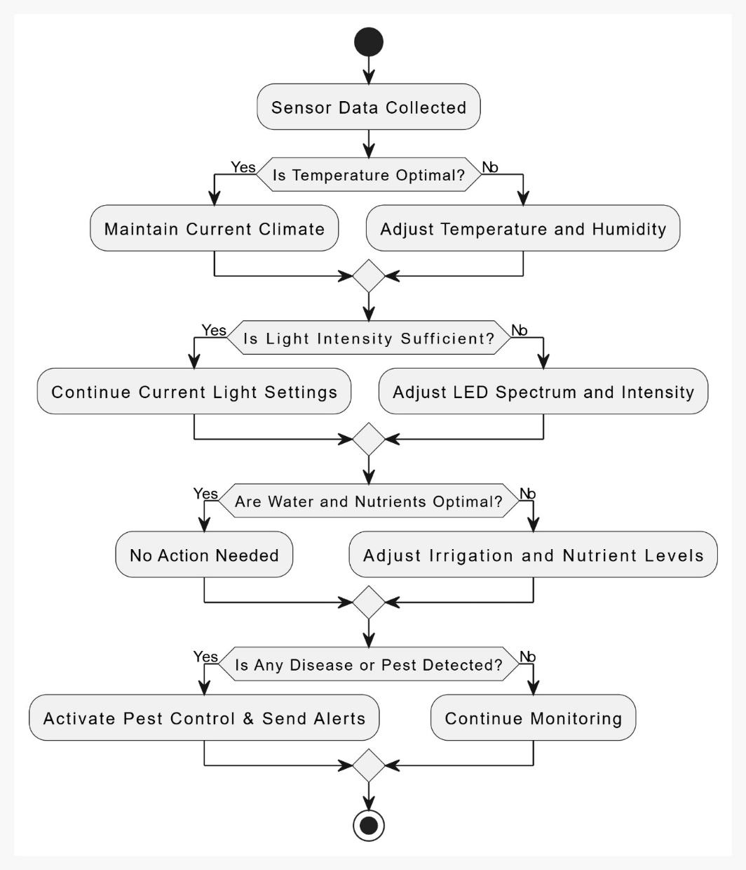

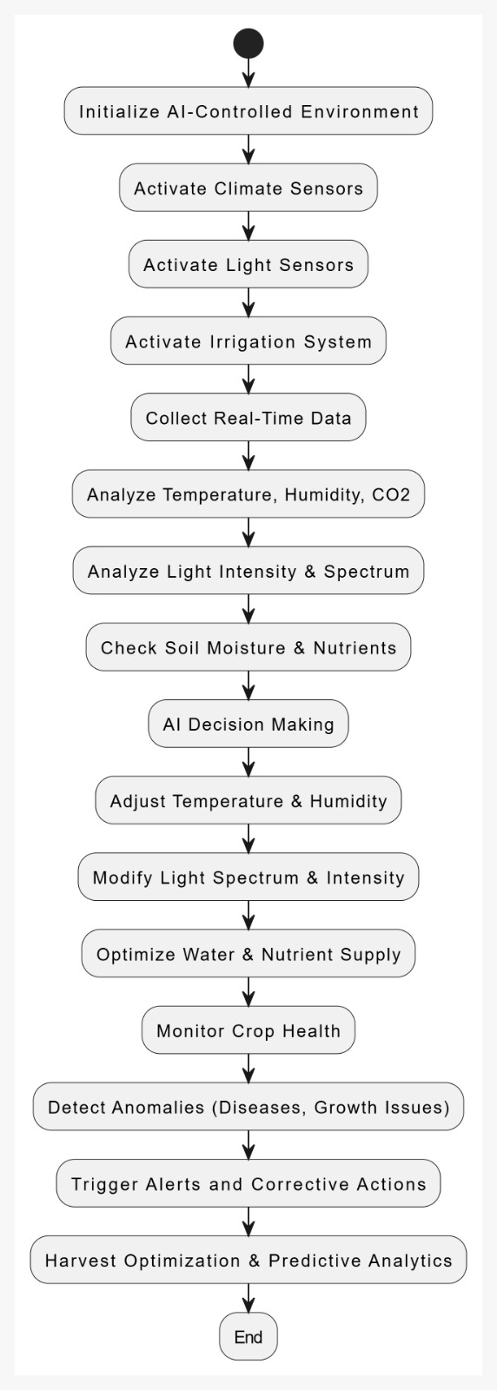

F. List of Companies Which Can Be Contacted for Commercialization:
- Mahindra Agri Solutions (mahindra.com/agri-solutions/)
- Godrej Agrovet (godrejagrovet.com)
- Reliance Retail (relianceretail.com)
- National Bank for Agriculture and Rural Development (NABARD) (nabard.org)

G. Working Prototype / Formulation / Design / Composition:
Prototype Overview:
While a fully operational working prototype is not yet available, the conceptual design and technical architecture of the AI-optimized outdoor farming system have been thoroughly developed. The system's design leverages established principles of precision agriculture, sensor technology, and artificial intelligence, integrated to address the specific challenges of outdoor farming, particularly within the Indian context.
The development of a working prototype is a key priority for future implementation. The prototype will be designed to demonstrate the system's core functionalities, including:
- Distributed Sensor Network Deployment: Implementation of a network of wireless sensors for real-time data collection on soil moisture, temperature, and other relevant environmental parameters.
- AI-Powered Control System Integration: Integration of machine learning algorithms for data analysis, predictive modeling, and automated decision-making.
- Automated Irrigation and Fertilization System Implementation: Demonstration of automated systems for precise water and nutrient delivery based on AI-driven recommendations.
- Cloud-Based Platform Development: Creation of a user-friendly cloud platform for data visualization, remote monitoring, and farmer interaction.
The prototype will be designed for scalability and adaptability, allowing for testing in diverse agricultural settings. Data collected from the prototype will be used to validate the system's performance, refine algorithms, and optimize resource management strategies. The development of this working prototype is anticipated to be a significant step toward the system's commercialization and widespread adoption.

H. Use and Disclosure:
H.1 Marketing:
Did we succeed in marketing it?
We are currently in the market development phase and are actively initiating contact with potential partner companies. We are confident that these strategic collaborations will accelerate our market entry.
H.2 Publications:
Has this invention been published anywhere?
We are currently maintaining confidentiality as we prepare comprehensive technical documentation. We believe this strategic release will effectively showcase the invention's potential and attract investment.
H.3 Collaborations:
Are we working with any other organizations?
We are currently focused on internal development, but we are actively planning to establish strategic partnerships with relevant organizations in the near future.
H.4 Regulatory Approvals:
Is approval needed?
Yes, we are fully aware that regulatory approvals will be essential. We've begun researching and planning for all necessary approvals, focusing on data privacy, environmental impact, agricultural input standards, and technology safety. We are also engaging with regulatory bodies to ensure a smooth process and demonstrate our commitment to compliance

H.5 Potential for Commercialization:
The AI-optimized outdoor farming system presents significant commercial potential, particularly within the Indian agricultural landscape. The system's ability to address critical challenges such as water scarcity, inefficient resource utilization, and climate variability positions it as a valuable solution for a wide range of stakeholders.
Key Commercial Opportunities:
- Smallholder Farmer Adoption: The system's affordability and user-friendly interface make it accessible to smallholder farmers, who constitute a significant portion of the Indian agricultural sector. The potential for increased yields and reduced input costs offers a compelling value proposition.
- Large-Scale Commercial Farming: The system's scalability and data-driven optimization capabilities make it suitable for large-scale commercial farming operations, enabling them to improve efficiency and profitability.
- Government Initiatives: The Indian government's focus on sustainable agriculture and food security creates opportunities for partnerships and collaborations with government agencies and agricultural extension services.
- Agricultural Input Companies: Partnerships with agricultural input companies (e.g., fertilizer, irrigation) can facilitate the distribution and integration of the system with existing farming practices.
- Agri-Tech Service Providers: The system's cloud-based platform and data analytics capabilities can be leveraged by agri-tech service providers to offer value-added services to farmers.
- Food Processing and Retail: The system's ability to improve crop quality and yield predictability can benefit food processing and retail companies seeking reliable sources of high-quality produce.
- Export Markets: The technology has the potential to be used in other countries that are facing similar Agricultural challenges.
The system's modular design, cloud-based platform, and AI-driven optimization capabilities allow for flexible deployment and adaptation to diverse farming environments. The integration of local weather data and crop-specific algorithms further enhances its effectiveness in the Indian context. By empowering farmers with data-driven insights and automated resource management, the AI-optimized outdoor farming system has the potential to transform agricultural practices and contribute to a more sustainable and prosperous future for Indian agriculture

I.FILING OPTIONS:
Our filing strategy reflects the confidence we have in the maturity of our innovation. We're choosing to proceed directly with a non-provisional application. This decision stems from the fact that our core idea is thoroughly developed and ready for implementation.
In contrast to situations where an idea is still in its nascent stages – perhaps half-formed and requiring further refinement – we believe a provisional application is not the most strategic path for us. While provisional applications certainly have their place in the patent process, we view them as most advantageous when an inventor is still exploring the contours of their concept.
Our idea has reached a point where we're focused on bringing it to life, not just defining it. We're excited to move forward decisively to secure robust protection for our work.

J. Keywords:
- AI-powered agriculture
- Precision agriculture
- Smart farming
- Automated farming
- Sustainable agriculture
- Outdoor farming
- Open-field agriculture
- Crop yield optimization
- Resource management
- Water conservation
- Fertilizer optimization
- Pest management
- Disease detection
- Sensor network
- Wireless sensors
- Machine learning
- Predictive analytics
- Cloud computing
- Remote monitoring
- Data analytics
- Irrigation automation
- Fertigation
- Variable rate application
- Weather data integration
- Indian agriculture
- Smallholder farmers

K. References & Acknowledgments:
The following patent documents were referenced in the development of this invention:
- U.S. Patent No. US10803312B2 to Genty et al.
- U.S. Patent No. US8533993B2 to Pettibone
We also acknowledge the valuable information and resources provided by:
- The United States Department of Agriculture (USDA) : www.usda.gov
- The Indian Government Agriculture Website : https://agriwelfare.gov.in/

